SUPW

PROJECT

Name: Souvik Pal.

Class: XII.

Section: A.

UID Number: 6842750.

TOPIC 1:

HELPING MY SOCIETY DURING THIS

PANDEMIC.

HELPING MY SOCIETY IN THIS PANDEMIC

A **pandemic** is an epidemic of an infectious disease that has spread across a large region, for instance multiple continents or worldwide, affecting a substantial number of people. Now, we are undergoing through a very serious condition of **COVID-19** Pandemic.



Coronavirus outbreak was first reported towards the end of 2019 and has now been declared a pandemic by the World Health Organization. Worldwide countries are responding differently to the virus outbreak.

In India, a **lockdown** is declared all over India. For this, there has been a huge economic crisis all over India.

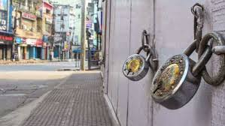

People are not allowed to come out of their houses. So, professionals like hawkers, day-workers, etc. are without any work and hence, any income. This made me a little morose. I thought of helping these people, at least in my locality. Moreover I thought of spreading awareness in the locality about Coronavirus Disease. To do so, I took the following steps:

* I made few **posters** on COVID-19 pandemic and posted them in the club of our locality. These posters will make people aware of the virus.

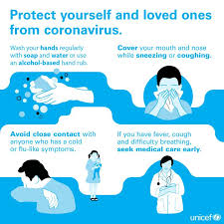 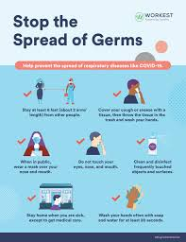

Moreover, it will help people to take the necessary precautions as discussed in the posters made by me.

* I **distributed food packets** in our locality, which was sponsored by the club-head of the club in our locality. I funded an amount of money in the club fund-raising scheme, and in the day of distribution, I distributed the food packets along with face-masks and hand-sanitizers.

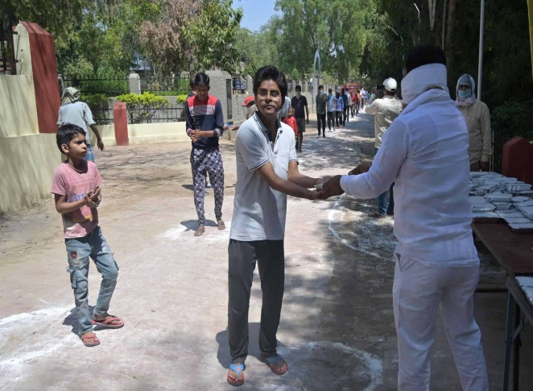 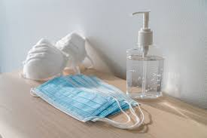

Besides these, I participated in many campaigns, along with my friends and club-members of our locality. Overall, I tried my best to stand by the people during this pandemic situation. I request to all to help the people suffering the most in this pandemic situation in terms of economy, by providing with necessary household items or funds, if possible. We, all are passing through a tough time. The researchers, along with the doctors are fighting day and night to fight against this disease. We all hope to win this fight and regain our past days of life.

TOPIC-2:

VISIT TO A COMMERCIAL BANK.

VISIT TO A COMMERCIAL BANK

A commercial bank is a financial institution which performs the functions of accepting deposits from the general public and giving loans for investment with the aim of earning profit. In fact, commercial banks, as their name suggests, axe profit-seeking institutions, i.e., they do banking business to earn profit.

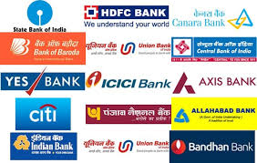

The banks generally finance trade and commerce with brief-time period loans. They price high fee of interest from the debtors but pay a good deal with much less charge of interest to their depositors with the result that the distinction between the two prices of interest becomes the main supply of earnings of the banks. The maximum of the Indian joint stock Banks is industrial Banks, which include Punjab national bank, Allahabad Bank, etc.

Recently, I visited a commercial bank in my locality, for some purpose. The name of the bank is **BANGYA GRAMIN VIKASH BANK,** the address of which is **Sarsuna Main Road, Near Behala Chaurasta, Kolkata, West Bengal, 700 061.**

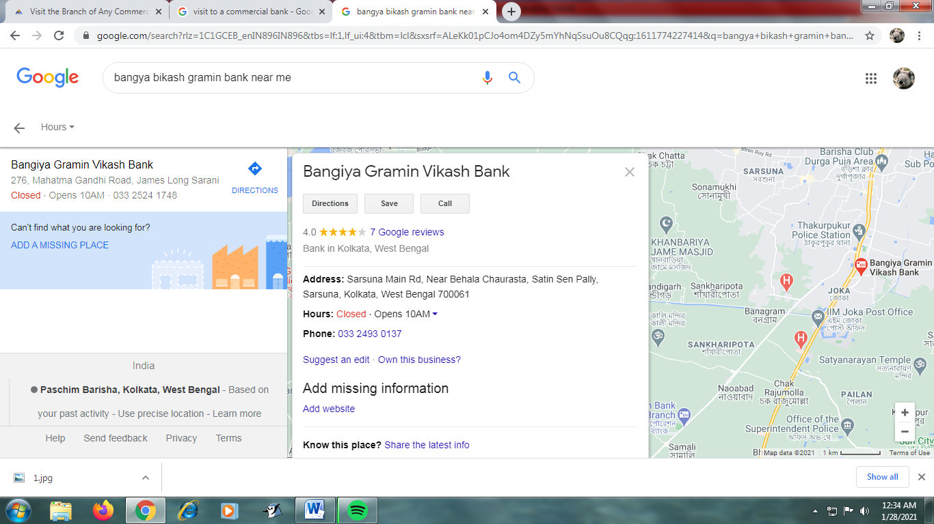

In this pandemic situation of COVID-19, every public places are taking necessary precautions. Similarly the said bank has also taken necessary precautions to prevent the spreading of COVID-19. The steps are as follows:

* Providing face- masks and sanitizers: While entering inside the bank, one of the co-workers provided me with a face-mask and a sanitizer. I was too glad to receive it, and so, I captured it in a photo as shown below.

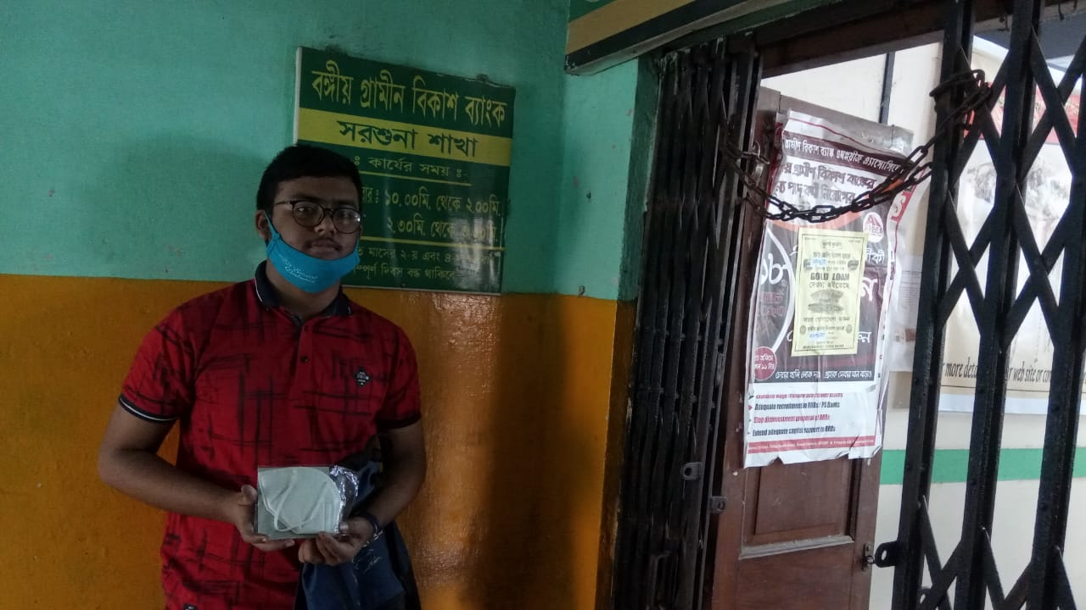

Face masks and Sanitizers are very much needed in this pandemic situation. This is a good initiative from the bank’s side. I appreciate it, and request to all to wear face-masks and carry sanitizers while coming out of their respective houses.

* Maintenance of social- distancing inside the bank: All of those who were present inside the bank were requested to maintain social distancing inside the bank. This is also a good precaution to prevent the spread of COVID-19.

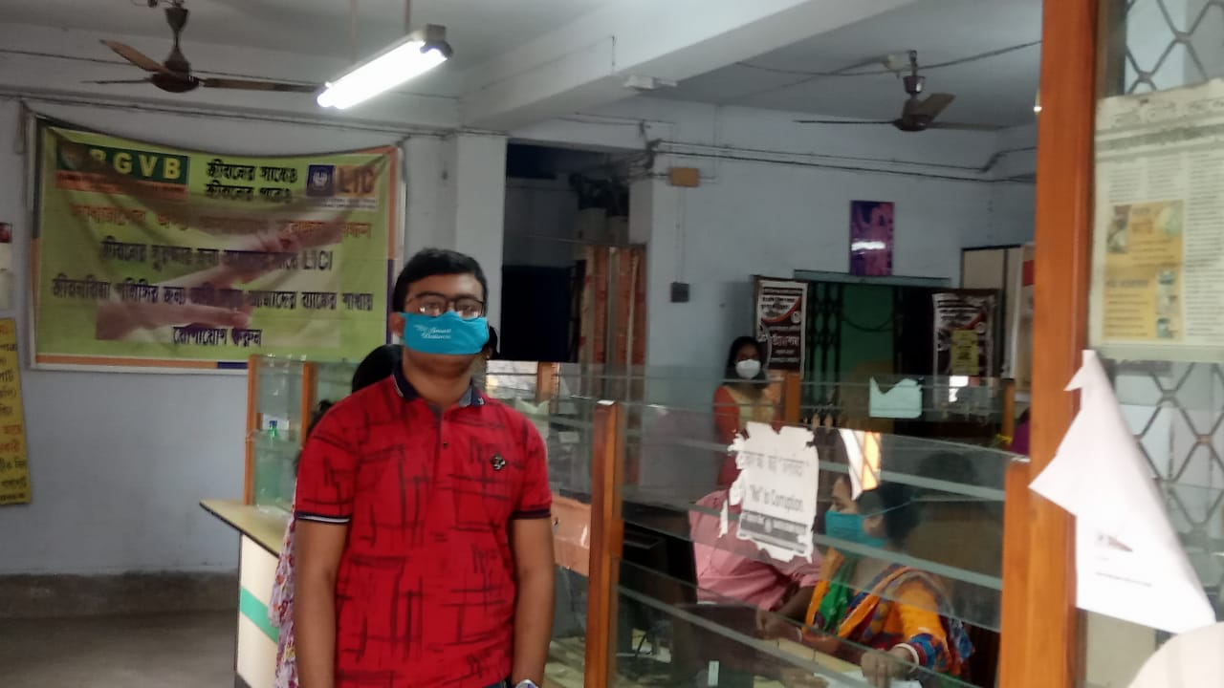

Keeping a set physical distance from each other and avoiding hugs and gestures that involve direct physical contact, reduce the risk of becoming infected during outbreaks of infectious respiratory diseases.Where possible it may be recommended to work from home.

Overall I am satisfied by the precautions taken by this bank, and I hope, other banks too take precautions like this to prevent the spread of Coronavirus.